Adventures in Global Partnership
The new rector of The Episcopal Church of the Holy Innocents, Beach Haven, NJ, The Rev. Dr. Caroline Carson, has just been on an adventure in Bangladesh. That’s a long way from New Jersey and she was not on vacation. What was she doing?
Mother Caroline is an exceptionally talented person. In addition to her recent ordination to the priesthood and call to serve at Holy Innocents’, she has a Masters of Divinity from Sewanee School of Theology, a Doctorate of Musical Arts in Conducting from the University of South Carolina, a Master of Conducting from Emory University and a Bachelor of Music Education from the University of South Carolina. This trip adds to her adventures from her recent grants, the Seminary Consultation on Mission (SCOM), the United Thank Offering (UTO), and with Episcopal Church Global Partnerships funding (with the SCOM grant). Carson was following up on last year’s Global Partnership visit to the Church of Bangladesh, the first official visitation from The Episcopal Church since The Most Reverend Ed Browning went to Dhaka in 1997. The goal for this mission partnership outreach process is to continue to help build relationships, if possible, parish to parish and/or diocese to diocese. She also provided the Church of Bangladesh assistance with their 2020 UTO grant application, sang with every group she visited, and brainstormed development and grant ideas with bishops around the various dioceses there.
Dr. Carson is a missioner interested in global partnerships, peacemaking, interfaith relationships, and Anglican ecumenism. A professor for 20 years, she continues to enjoy conducting and singing professionally. Caroline is also a member of the Episcopal Communicators and a volunteer with the NASA Solar System Ambassador Program. She has a high energy and enthusiasm for life and is dedicated to discipleship, learning, pastoral sensitivity, missional engagement, and recognizing the movement of the Holy Spirit in each person. (https://www.worldanglican.com/united-states/beach-haven/the-episcopal-church/the-rev-dr-caroline-carson )
The Rev. Carson provided her congregation back home with a running account of her adventures. The whole story from her trip is on the Holy Innocents’ Facebook page: https://www.facebook.com/HIBeachHavenNJ/
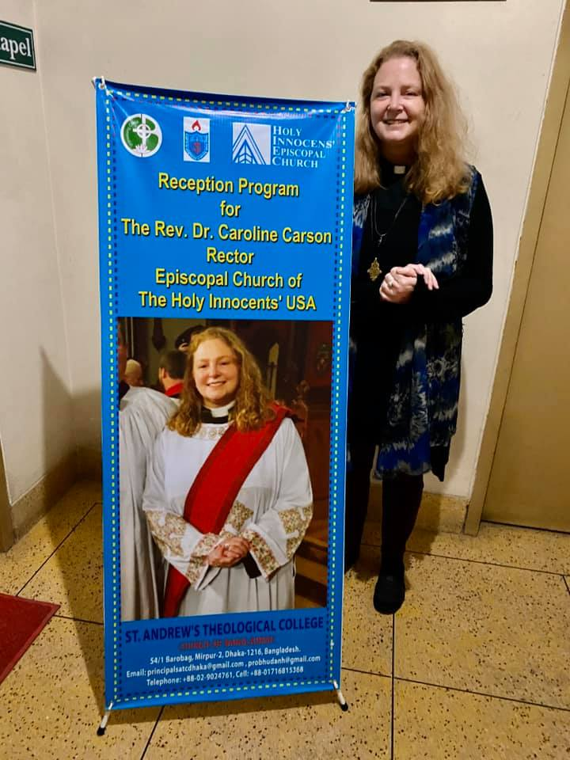
1/28/2020
Rector’s note: I arrived safely into Dhaka, Bangladesh and am staying at St. Andrew’s Theological College. I received a VERY warm welcome and the group here sends many prayers and greetings to you! There was a reception program in the theological library and I met several students and some seminary staff as well as the Dean and choir director. They sang me a hymn and we shared introductory greetings and then we had a question and answer time. They graciously gave me a gorgeous shawl...and I’m sure you noticed the BANNER, WOW! That was a really sweet surprise!
Tomorrow, I’ll participate in morning worship, teach a class, see the cathedral and another large church, talk to the Moderator (primate there), Synod staff and others.
The Episcopal Church Global Partnerships website (https://episcopalchurch.org/global-partnerships describes its mission and ministry this way:
The ministry of the Office of Global Partnerships is to help “build bridges beyond ourselves”. We serve as a bridge for developing and nurturing relationships between The Episcopal Church and our partners around the Anglican Communion, our ecumenical and interreligious partners, and with organizations such as the United Nations and the National Council of Churches. We are a resource for congregations and dioceses as they develop and foster their own relationships around the world. We actively develop resources to strengthen and facilitate the global mission engagement of The Episcopal Church. We highlight issues of international concern and, in cooperation with colleagues on the Presiding Bishop’s staff mobilize engagement in these issues throughout The Episcopal Church. Our ministry is guided by the mission priorities adopted by General Convention, and the mission priorities of the Presiding Bishop of Evangelism, Reconciliation, and Care of Creation.
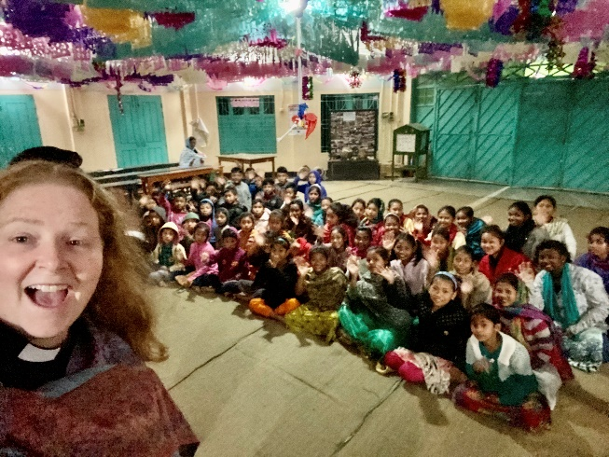
The Rev. Canon Bruce Woodcock, Partnership officer for Asia and the Pacific, says “Similar Asia Pacific partnership development efforts are envisioned for several Anglican Communion partners, such as Korea (ACK) Japan (NSKK) and the Philippines (ECP) among others under consideration in Oceania (ANZP). My hope is that Caroline+ can also help make a similar connection (perhaps for Dioceses and Parishes in Province 2) with the Anglican Church in Ceylon perhaps in May 2020, if travel support can be located.”
1Canon Woodcock: "With great thanks to Caroline Carson+and the Church of Bangladesh for making this partnership visit "
Global Partnerships are formed by networking and story-telling. Dr. Carson will share her story with her congregation in NJ and with the Diocese of NJ, at least. All too often we hear about the disasters and exploitation in Bangladesh but nothing about the vibrant Christian community in the Anglican tradition that welcomes connections, prayers and support.
Any congregation can get involved. There are resources on the Global Partnerships website at https://episcopalchurch.org/global-partnerships/resources . One example is Carson’s trip, but that’s not the only possibility. There are covenant and bilateral relationships that bring churches together. https://episcopalchurch.org/bilateral-and-covenant-relationships . Groups from around the world have formed official links, finding their rewards in new friendships, mutual learning, and an expanded awareness of the world. Together, they share prayers and fight poverty, throughout the Church and abroad. Groups in mission relationships take on responsibility for each other. https://episcopalchurch.org/page/mission-relationships . Our young people are always ready to get involved with partnerships. St. Andrews School in Maryland has international partnerships with Haiti and with Bokamoso, South Africa.
Mother Caroline spent an exhausting week on a whirlwind tour. We can all look forward to seeing what comes next. What will result from these friendships newly forged? Where will she go next? We’re waiting to find out. Meanwhile, just look at all she accomplished!
1/29/2020
Rector’s update: Yesterday (Wednesday, Jan. 29), I attended Morning Prayer in the Theological College, met with students to talk about practical ministry, discernment, wellbeing for clergy, and being a pastor/preacher/teacher in the world today. We also shared some singing. Then, I visited St. Thomas cathedral and the Church of Bangladesh offices. When I got out of my car, I saw myself on a tree! There was a short program of welcome led by the Moderator (primate) Samuel S. Mankhin and I was given a plaque. Afterwards, it was wonderful to share lunch with his grace and his assistant Prodip. Later, I met to talk about grant writing, a UTO (United Thank Offering) grant project, asset-based community development (ABCD), and more. Archbishop Mankhin asked me to come and say hello to visiting Coptic Orthodox bishops who actually know three people I know in the new province of Egypt, N. Africa, and the Horn of Africa. It was a laughter-filled discovery and an amazing moment of just how small the world is (and they liked my Coptic cross!) Evening Prayer was held in St. Thomas Cathedral before dinner. I’d forgotten how spicy the curries are, WOW! I hope you’ll enjoy these little video clips (if they show up!) and photos from a moving car. Hopefully, it’ll give you an idea of life in Dhaka. Wednesday evening, we left to northern Bangladesh by overnight steamer on the Burigonga River to the Kirtonkhola River. It was dark and foggy and rumbled like crazy. Not sure of upcoming internet availability as I’m going to be in and out if smaller villages. More in a bit with what I experienced today.
Rector’s update: Sunday, while Canon Woodcock was with you (The Rev. Canon Bruce Woodcock was the celebrant and preacher filling in for Carson at Holy Innocents’ on February 2, 2020), I preached at St. John’s Cathedral in the Kushtia diocese and served with Bishop Hemen Haldar. After lunch, it was time to head off to Lalon Shah - Bengali philosopher, Baul saint, mystic, songwriter, social reformer and thinker from the Indian subcontinent. He was an icon of Bengali culture, inspiring and influencing many poets, social and religious thinkers including Rabindranath Tagore. There at the shrine area, we heard a fantastic music group with singer Babo Shah. We then drove north four hours to Idilpur parish. It is the area of the Garu tribal indigenous people, also known as “mandthee” or “original man.” Here, there is a “Children’s Village” where poorest families may send their children to grow up having education and enough food. Last night, I taught the kids three songs. I also heard a Garu group practicing for a worship service.
And there’s more on the Facebook page of Holy Innocents’!

